|  |
| --- |
| **Ahsanullah University of Science & Technology**  Department of Computer Science & Engineering  **FALL 2021**  **logo.jpg** |
| Zootopia |
| CSE 3104: Project Report |
|  |
| Submitted By: |
|  |

|  |  |
| --- | --- |
| ID | NAME |
| 190204010 | Sadia Islam |

Table of Contents:

1. Motivation of the project: 3

2. Project Goal 3

3. Project Cost Calculation 3

4. Potential Customers 4

5. Requirement Analysis 4

6. Entity Relationship Diagram 6

7. Project Risk 7

8. Conclusion 7

1.**Motivation of the project:**

1. Providing the **facility of managing all the animals and maintaining a healthy environment for them.**

**2. Managing the activity of workers in the zoo.**

**3. Reduction the paper work, resulting in reduction of human effort or manual labor.**

**2.** **Project Goal****:**

1.The main goal of this project is to maintain the all-animal data, animal food and medicine data records.

2. Managing the workers and employees’ activities.

3. Making the whole process less time consuming.

**3.** **Project Cost Calculation****:**

Time required to complete: 8 weeks.

Considering 4 people working on the projects for 8 weeks, one day each week:

Salary of the software developer team = 25000(Approximately) monthly.

Payment for the team for each working day will be = 1200 BDT.

So, payment for the team for developing the software in 8 weeks will be = 9600 Taka BDT.

Utilities such as internet cost would be around 1000 BDT

For selling the software, we would consider starting the price from

* 8,500 BDT/Month
* 91,800 BDT/Year

**4. Potential Customers:**

* Authority of the zoo.

**5. Project Requirement Analysis:**

Feature of the software:

* Login-Registration: Employee will login to the software using the username and password provided.
* Manage employee information: This software shall have a manage employee info page where admin maintain employee all information. Admin will able to add, edit, view and delete employee information.
* Manage Animal Information: This software shall have a Manage animal info page where admin and employee maintain animal all information such as number of cells, name of the animal of the species, timing of vaccine of all animal. Admin and employee will able to add, edit, view and delete animal information.
* Manage Animal food Information: This software shall have a Manage animal food page where admin and employee maintain animal food. Admin and employee will able add, edit, view, and delete of animal food info.
* Manage Animal Medicine Information: This software shall have a Manage animal medicine page where admin and employee maintain animal medicine. Admin and employee will add, edit, view, and delete of animal medicine Info.

Software Requirements:

Front End: NetBeans IDE 8.0.2

Back-End: SQL Server Management Studio

**Project Possible Entity, Relationship and Attributes**

Possible Entity:

1. Animal

2. Enclosure

3. Employee

4.Animal_Food

5. Animal_Medicine

6. Import

7.Expense

8. Vet

Possible Relationship:

1. Lives
2. Working
3. Eats
4. Take
5. Being
6. Has
7. Prescribes
8. Assign

Possible Attributes (with primary & foreign key):

1. Animal: animal_id (primary key),animal’s name, country of birth,species,gender,weight, cell no(foreign key)
2. Enclosure : cell no (primary key), employee_id(foreign key), total_no_animal,cell_type,location
3. Employee: employee_id(primary key), name, hire_date, address,

e-mail, salary,gender, joining date, age, shifting_time

1. Animal_Food: food_type_id(primary key), species (foreign key),quantity,food_name,feed_time
2. Animal_Medicine: medicine_order_id(primary key),medicine_brand, medicine quantity, received date, species medicine
3. IMPORT: Import_id(primary key), animal_id(foreign key),animal_name,entry,import_cost,age_during_import
4. Expense: Expense_id(primary key),food_cost, medicine_cost,cleaning_cost, service_charge.
5. Vet: vet_id(primary key) ,employee_id(foreign key),vet_name ,head_vet, specialty,veternity_experience.

**6. ER Diagram:**

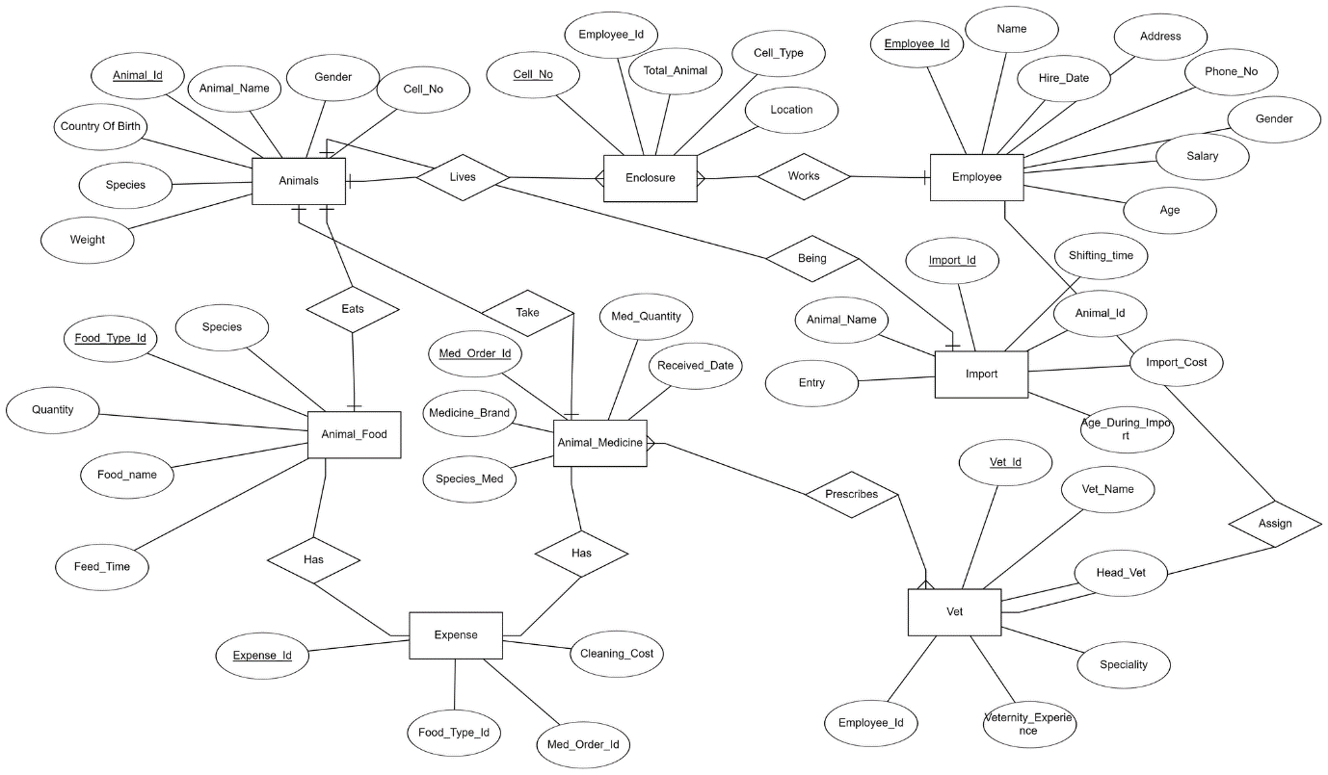

**7.Risk Analysis/ Possible Challenges:**

1. Since the progress of the project is going on, it might be a challenge to fulfill all the requirements in time.
2. Selling price of our software might not meet the expectation or budget of the buyers, so it might be needed to adjust mutually.

**8.Conclusion:**

The purpose of developing this software is to track of all types of animals and others information of a zoo. The system is user friendly and efficient for storing data. It will be helpful for animal conservation by ensuring the proper food and medicine supply for the animals.

1. **Output:**

Home page:

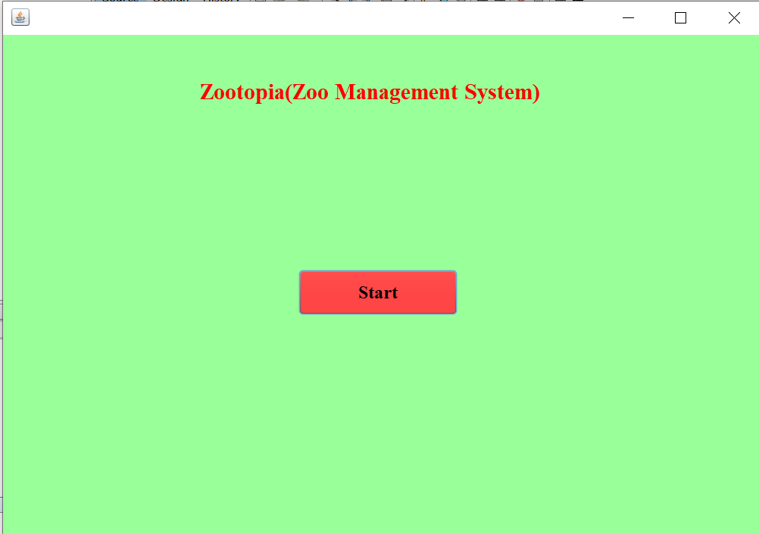

Login page for Admin:

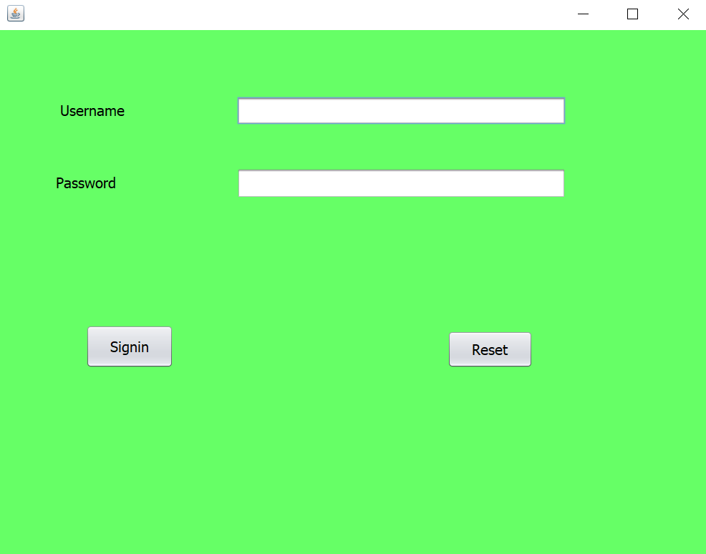

Tables:

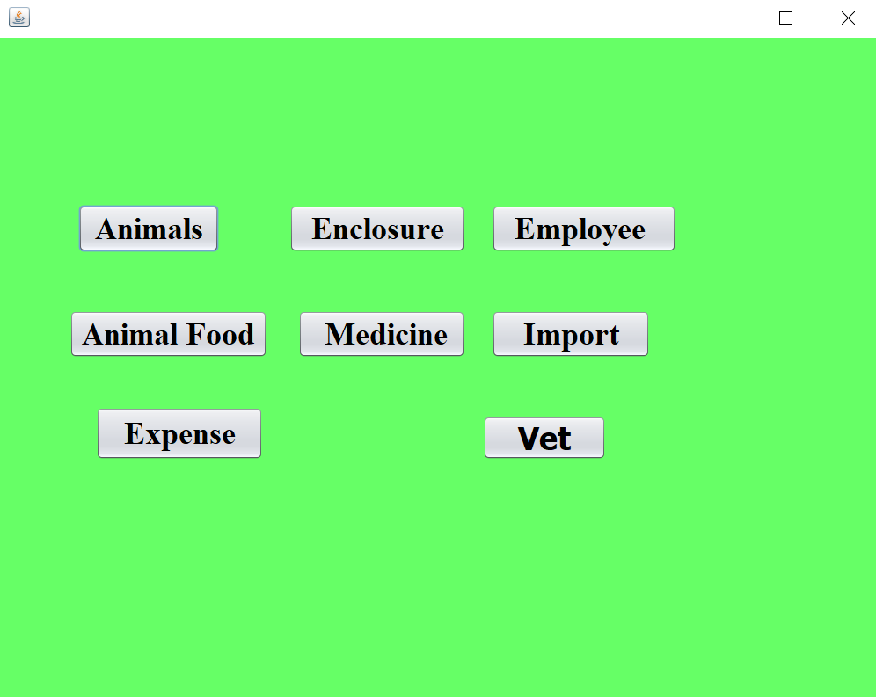

Animal Information:

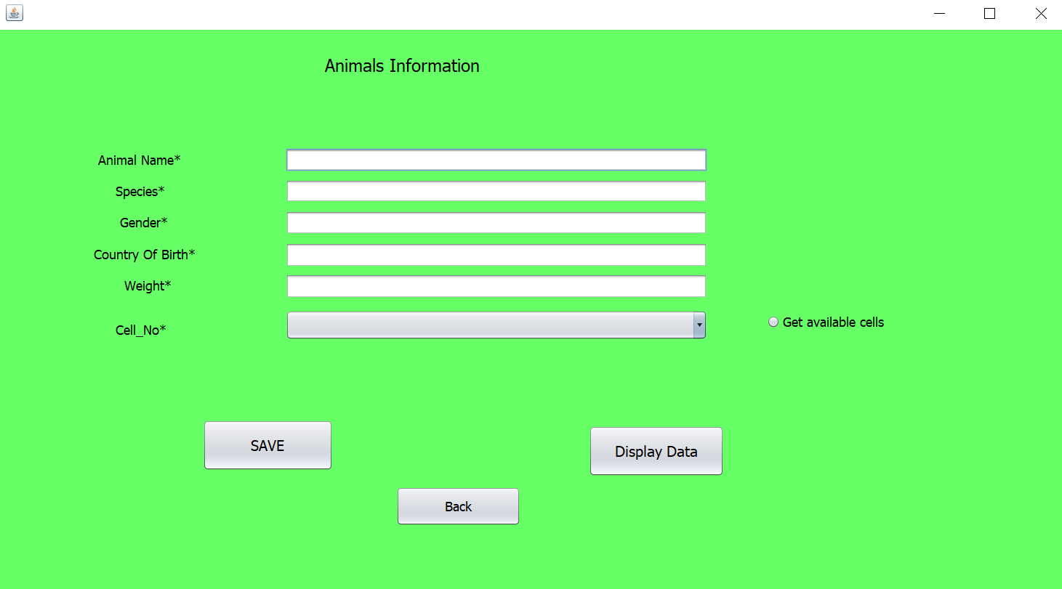

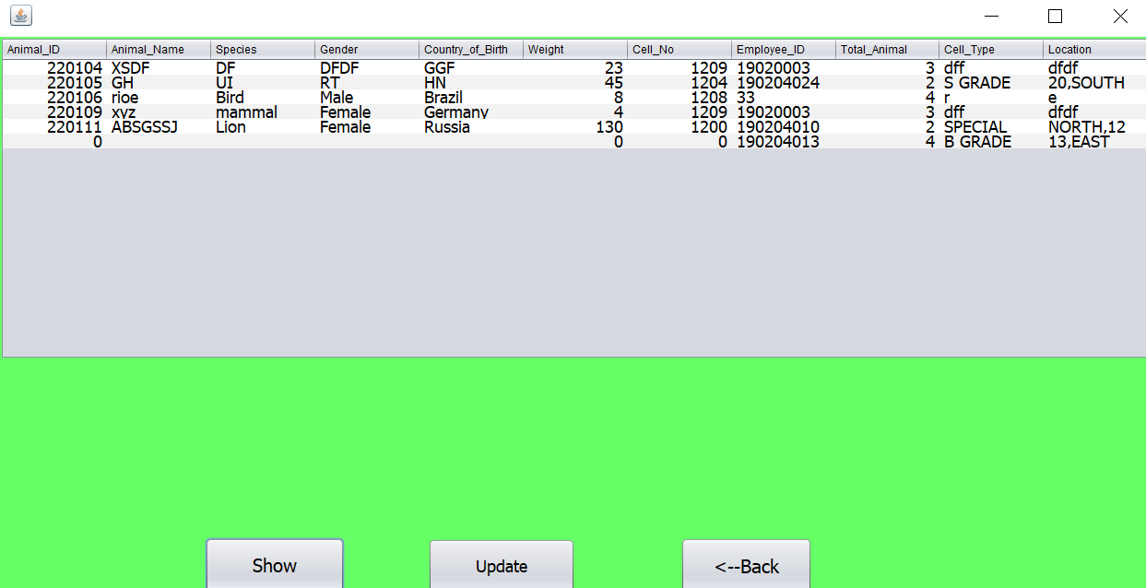

Animal Enclosure:

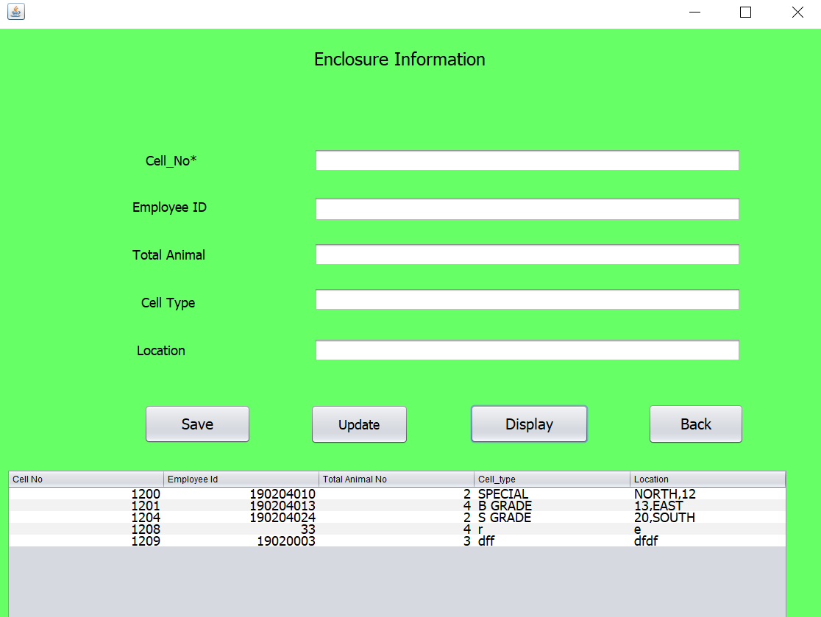

Employee Information:

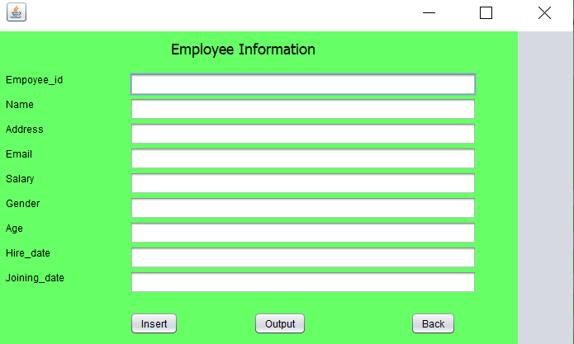

Animal Food:

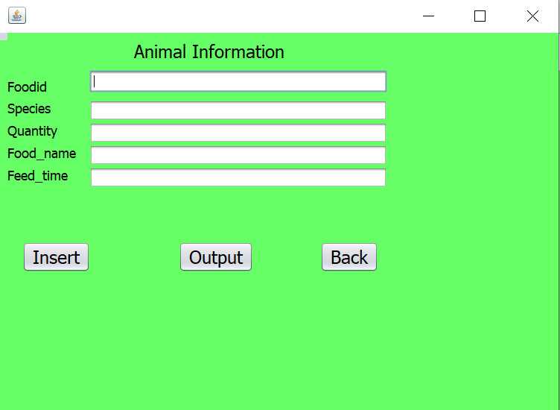

Animal Medicine:

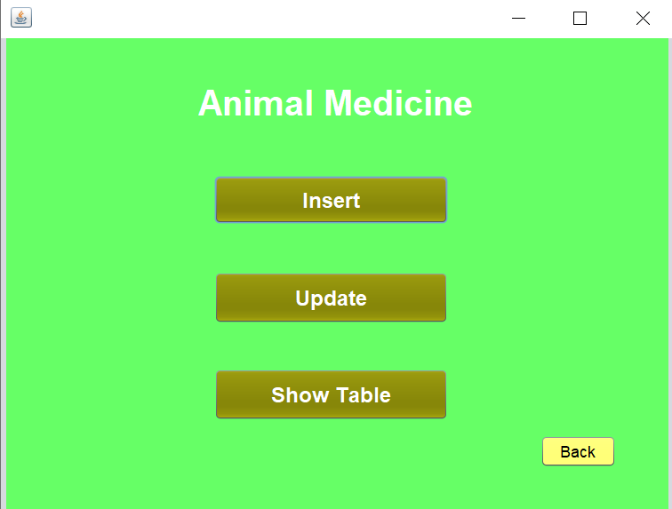

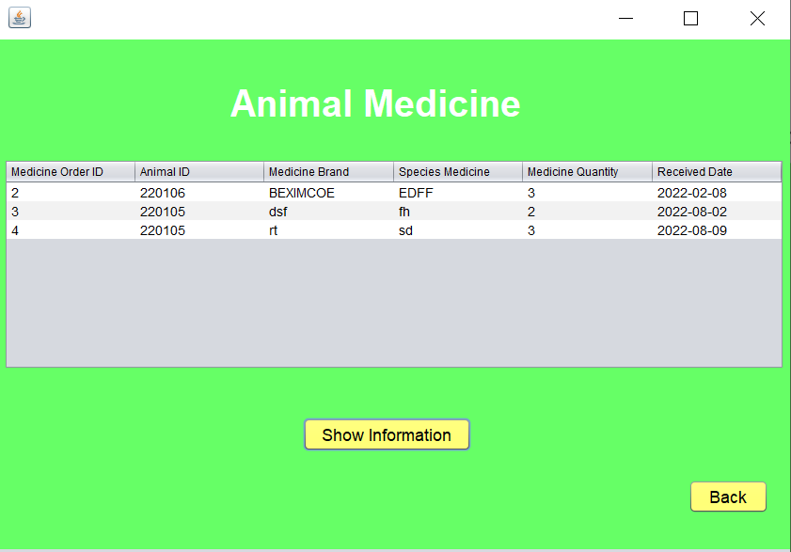

Animal Import Information:

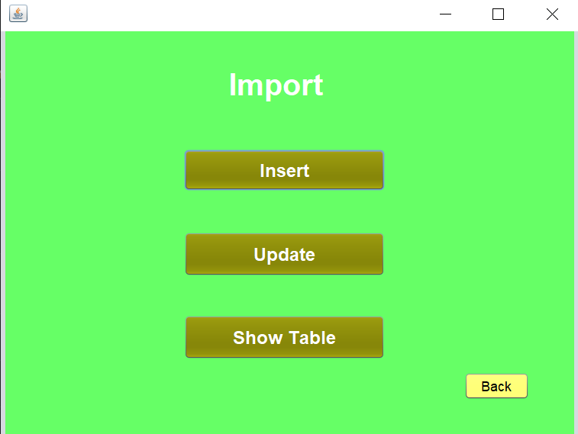

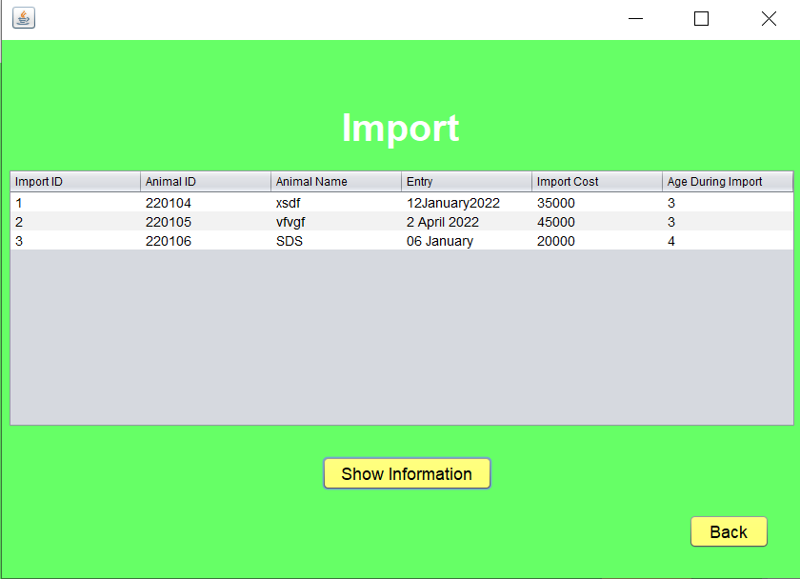

Animal Expense:

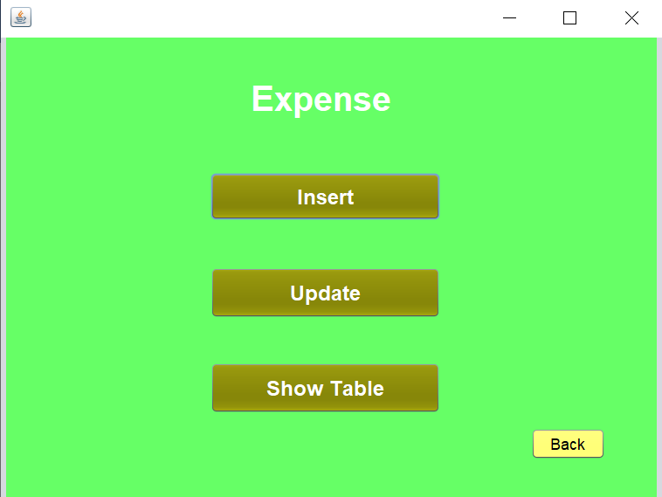

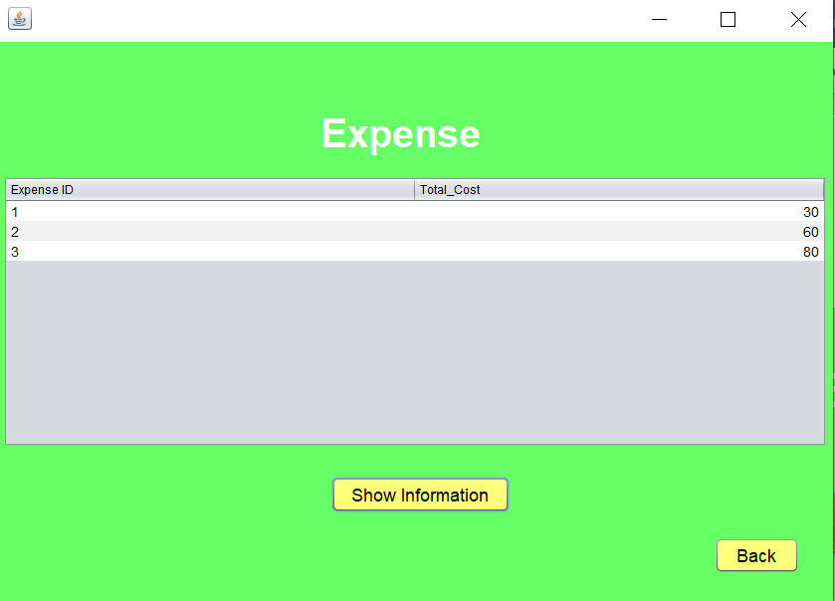

Vet Information:

